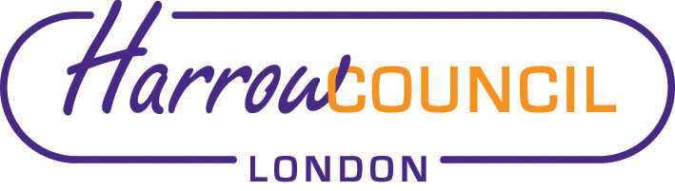
Harrow SACRE Meeting

Tuesday 8 March 2022 at 7.30 p.m.
To be held via video conferencing

Enquiries & apologies to:
Vivian Wright, Clerk to SACRE
vmwright@waitrose.com

Adviser to SACRE: Lesley Prior

Agenda
- Welcome especially new members Heena Mistry (NAHT) and Elizabeth Boulter (NEU).

- Apologies for absence:

- Minutes of the last meeting on 2 December 2021 and extraordinary meeting 13 January 2022 (attached): to agree the minutes as a true record.

- Matters arising from the minutes

- Local and National updates

- ASC
- Elect a chair
- Convene first meeting

- Annual report for NASACRE

- News from Faith Groups relating to schools

- Any Other Business

- Future Dates

- Thursday 23 June 2022
- Wed 14 Sep 2022
- Tues 6 Dec 2022
- Wed 1 March 2023

